Case 10-MEX-Maya-Central Lowlands-Shell Trumpet-250-400 CE

-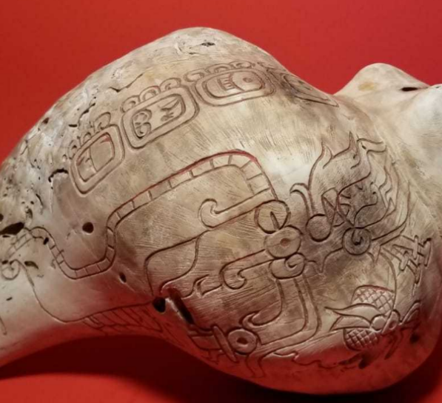

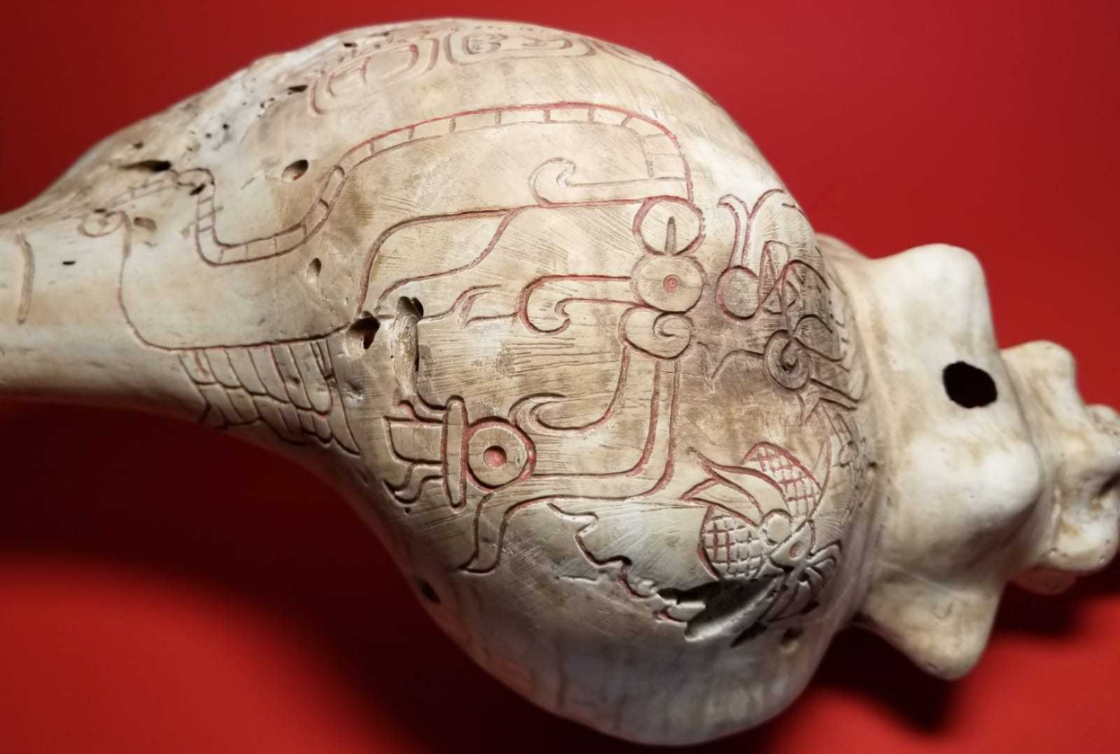

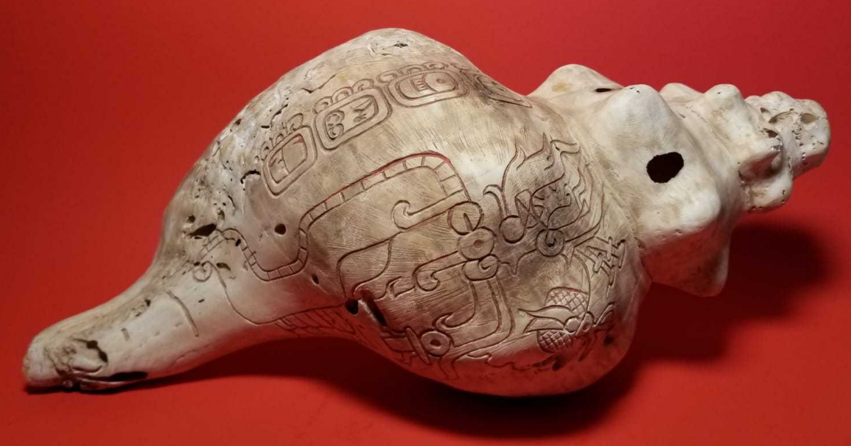 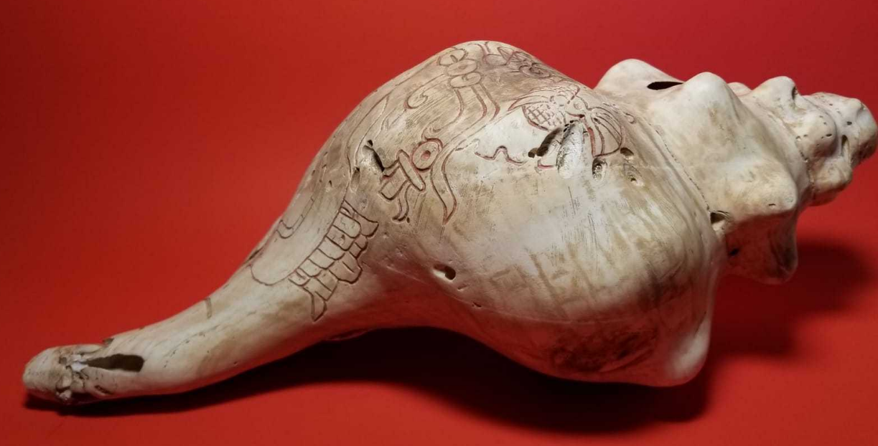 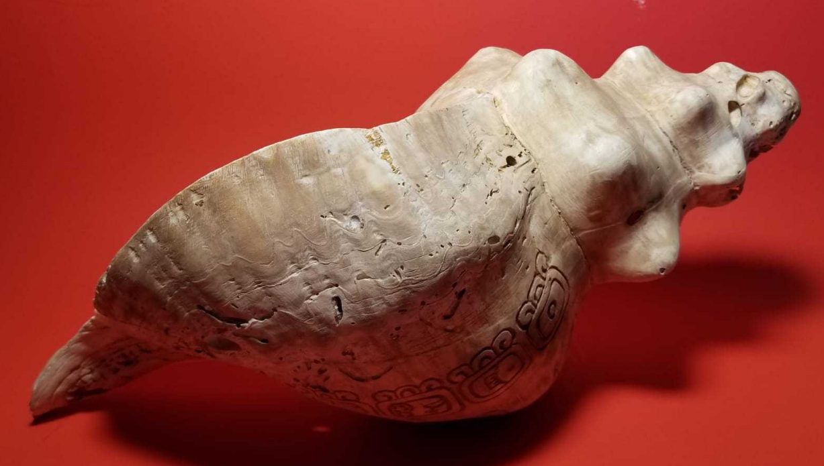

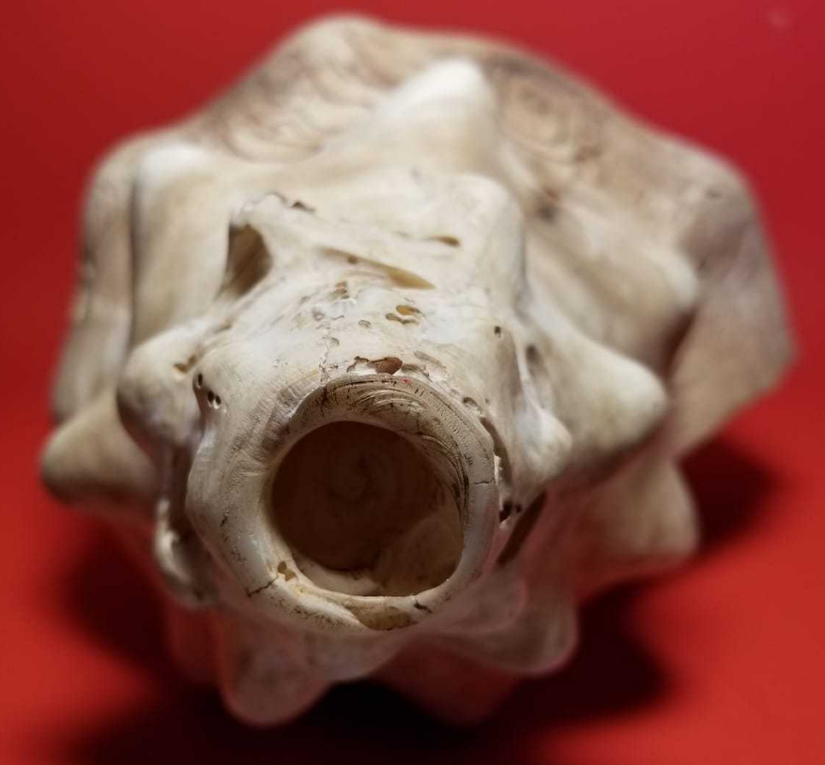

**Case no.: 14**

**Accession Number:**

**Formal Label:** Maya-Shell Trumpet-250-400 CE

**Display Description:** Throughout Mesoamerican history, conch shells were modified and used as trumpets. The conch functioned as a symbol of the sea for the Maya and other ancient peoples of Mesoamerica.  Its basic shape and function as a wind instrument also connected it to Maya symbolism of breath and wind.  On this shell trumpet, a royal headdress incorporates a water lily jaguar sign with the king’s name in four glyphs. Central Lowlands, Maya Area. Conch shell.

**LC Classification:**

**Date or Time Horizon:**

**Geographical Area:**

**Map:**

**GPS coordinates:**

**Cultural Affiliation:**

**Media:**

**Dimensions:** L 13 in, 7 in Diameter (widest section)

**Weight:**

**Condition:**

**Provenance:**

**Discussion:**

**References:**